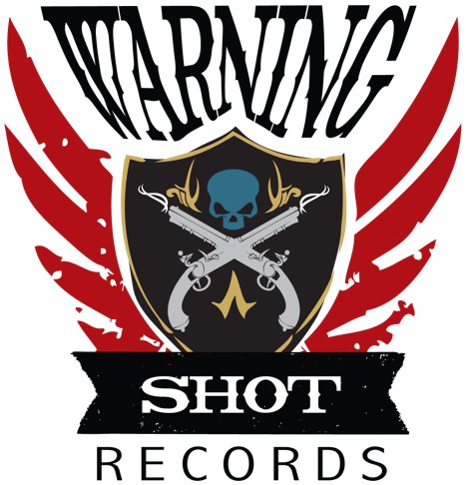
2020 In My Rearview Lyrics
© Warning Shot Records, Catlea
December 8, 2020

Been in a tunnel four dark years
Back against the wall with mounting fears
Wondering if there’s light at the end
Or if it’s the end of the light

I’m putting 2020 in my rearview
Running fast to the next year
Catch you on the flip side
Gonna party all night
Dance until the daylight, daylight

Let’s celebrate
One love
One world
One you
One me

Who do you love?
Find them
Who do you love?
Tell them

One love
One world
One place to be

Who do you love?
Tell them
Who do you love?

Got empty words in my ears and mouth
They go in one and they fall right out
Wishing for something when nothing’s been done
And the world is burning down

I’m putting 2020 in my rearview
Running fast to the next year
Catch you on the flip side
Gonna party all night
Dance until the daylight
Daylight

Let’s celebrate
One love
One world
One you
One me

Who do you love?
Find them
Who do you love?
Tell them

One love
One world
One place to be

Who do you love?
Find them
Who do you love?

One love
One world
One place to be

One love
One world
One place to be

One love
One world
One place to be

One love
One world
One place to be

Let’s celebrate
One love
One world
One place to be
Who do you love?
Find them
Who do you love?
Tell them
Who do you love?
Find them

Who do you love?
Who do you love? (Who do you love?)
Who do you love? (Who do you love?)
Who do you love?

One love
One world
One you
One me

